DT4GCS—Digital Twin for Geological CO₂ Storage & control
Felix J. Herrmann
Georgia Research Alliance Eminent Scholar Chair in Energy
[Seismic Laboratory for Imaging and Modeling]
Schools of Earth & Atmospheric Sciences, Computational Science & Engineering, Electrical and Computer Engineering
[Georgia Institute of Technology]
[https://slim.gatech.edu]

Abstract
Our industry is experiencing significant changes due to AI and the challenges of the energy transition. While some view these changes as threats, recent advances in AI offer unique opportunities, especially in the context of Digital Twins for subsurface monitoring and control. IBM defines “A digital twin is a virtual representation of an object or system that spans its lifecycle, is updated from real-time data, and uses simulation, machine learning and reasoning to help decision-making.” During this talk, we will explore these concepts and their significance in addressing the challenges of monitoring & control of geological CO₂ storage projects. This talk also aims to illustrate how Digital Twins can serve as a platform to integrate the seemingly disparate and siloed fields of geophysics and reservoir engineering.
Reservoir monitoring systems struggle to capture uncertainty in a principled way due to the large problem sizes, the complexity of the nonlinear relationships between reservoir properties, multiphase flow, and the seismic response. However, it can be argued that the root issue is that our simulators are ill-suited for statistical inference. To address this, Digital Twins can benefit from recent breakthroughs in generative AI and simulation-based inference (SBI). This raises the question of how Digital Twins can utilize generative AI. Deep generative networks, akin to advanced denoisers, can be trained to transform Gaussian noise into realistic samples of a specific distribution, whether it’s images or CO₂ plumes. Moreover, this generative process can be conditioned on various data types, including geophysical data. In a physics-based context, SBI enables domain experts like geophysicists and reservoir engineers to conduct principled statistical inference on field data by training deep networks on physics-based computer simulations. These principles of SBI will be demonstrated in a prototype Digital Twin for underground-storage monitoring.
To facilitate Simulation-Based Inference (SBI) in dynamic environments, a recursive approach is suggested, utilizing Digital Twins trained on simulations that reflect the reservoir’s current state, such as the CO₂ saturation, alongside collected field data from wells or seismic sources. See Figure 1. After training, these Digital Twins deduce the system’s state from new time-lapse field data. This method involves sequentially generating samples from a previous state, simulating them to predict the current state, and then conditioning these predictions on real-world observations from wells or seismic imaging. This cycle is intended to span the full duration of a CO₂ storage project, ensuring continual adaptation and accuracy improvement.
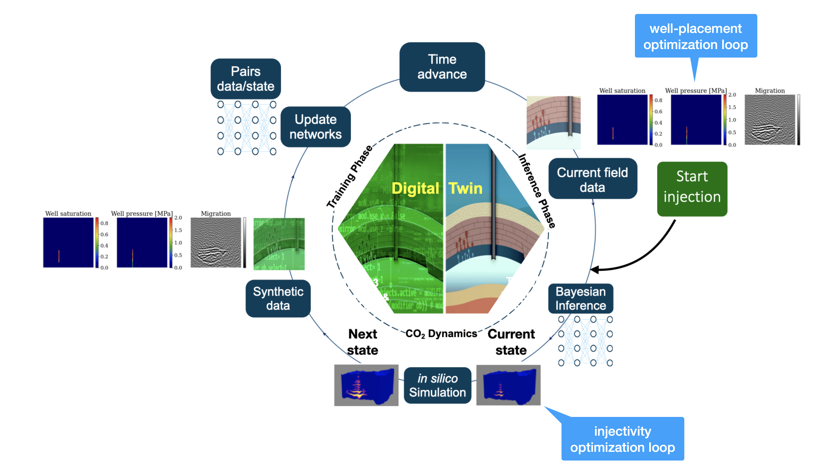
Figure 1: Digital Twin (DT4GCS) for Geological Carbon Storage including control of well-placement and injection-rate optimization. This DT is driven by CO₂ saturation and pressure at the well and by imaged seismic.

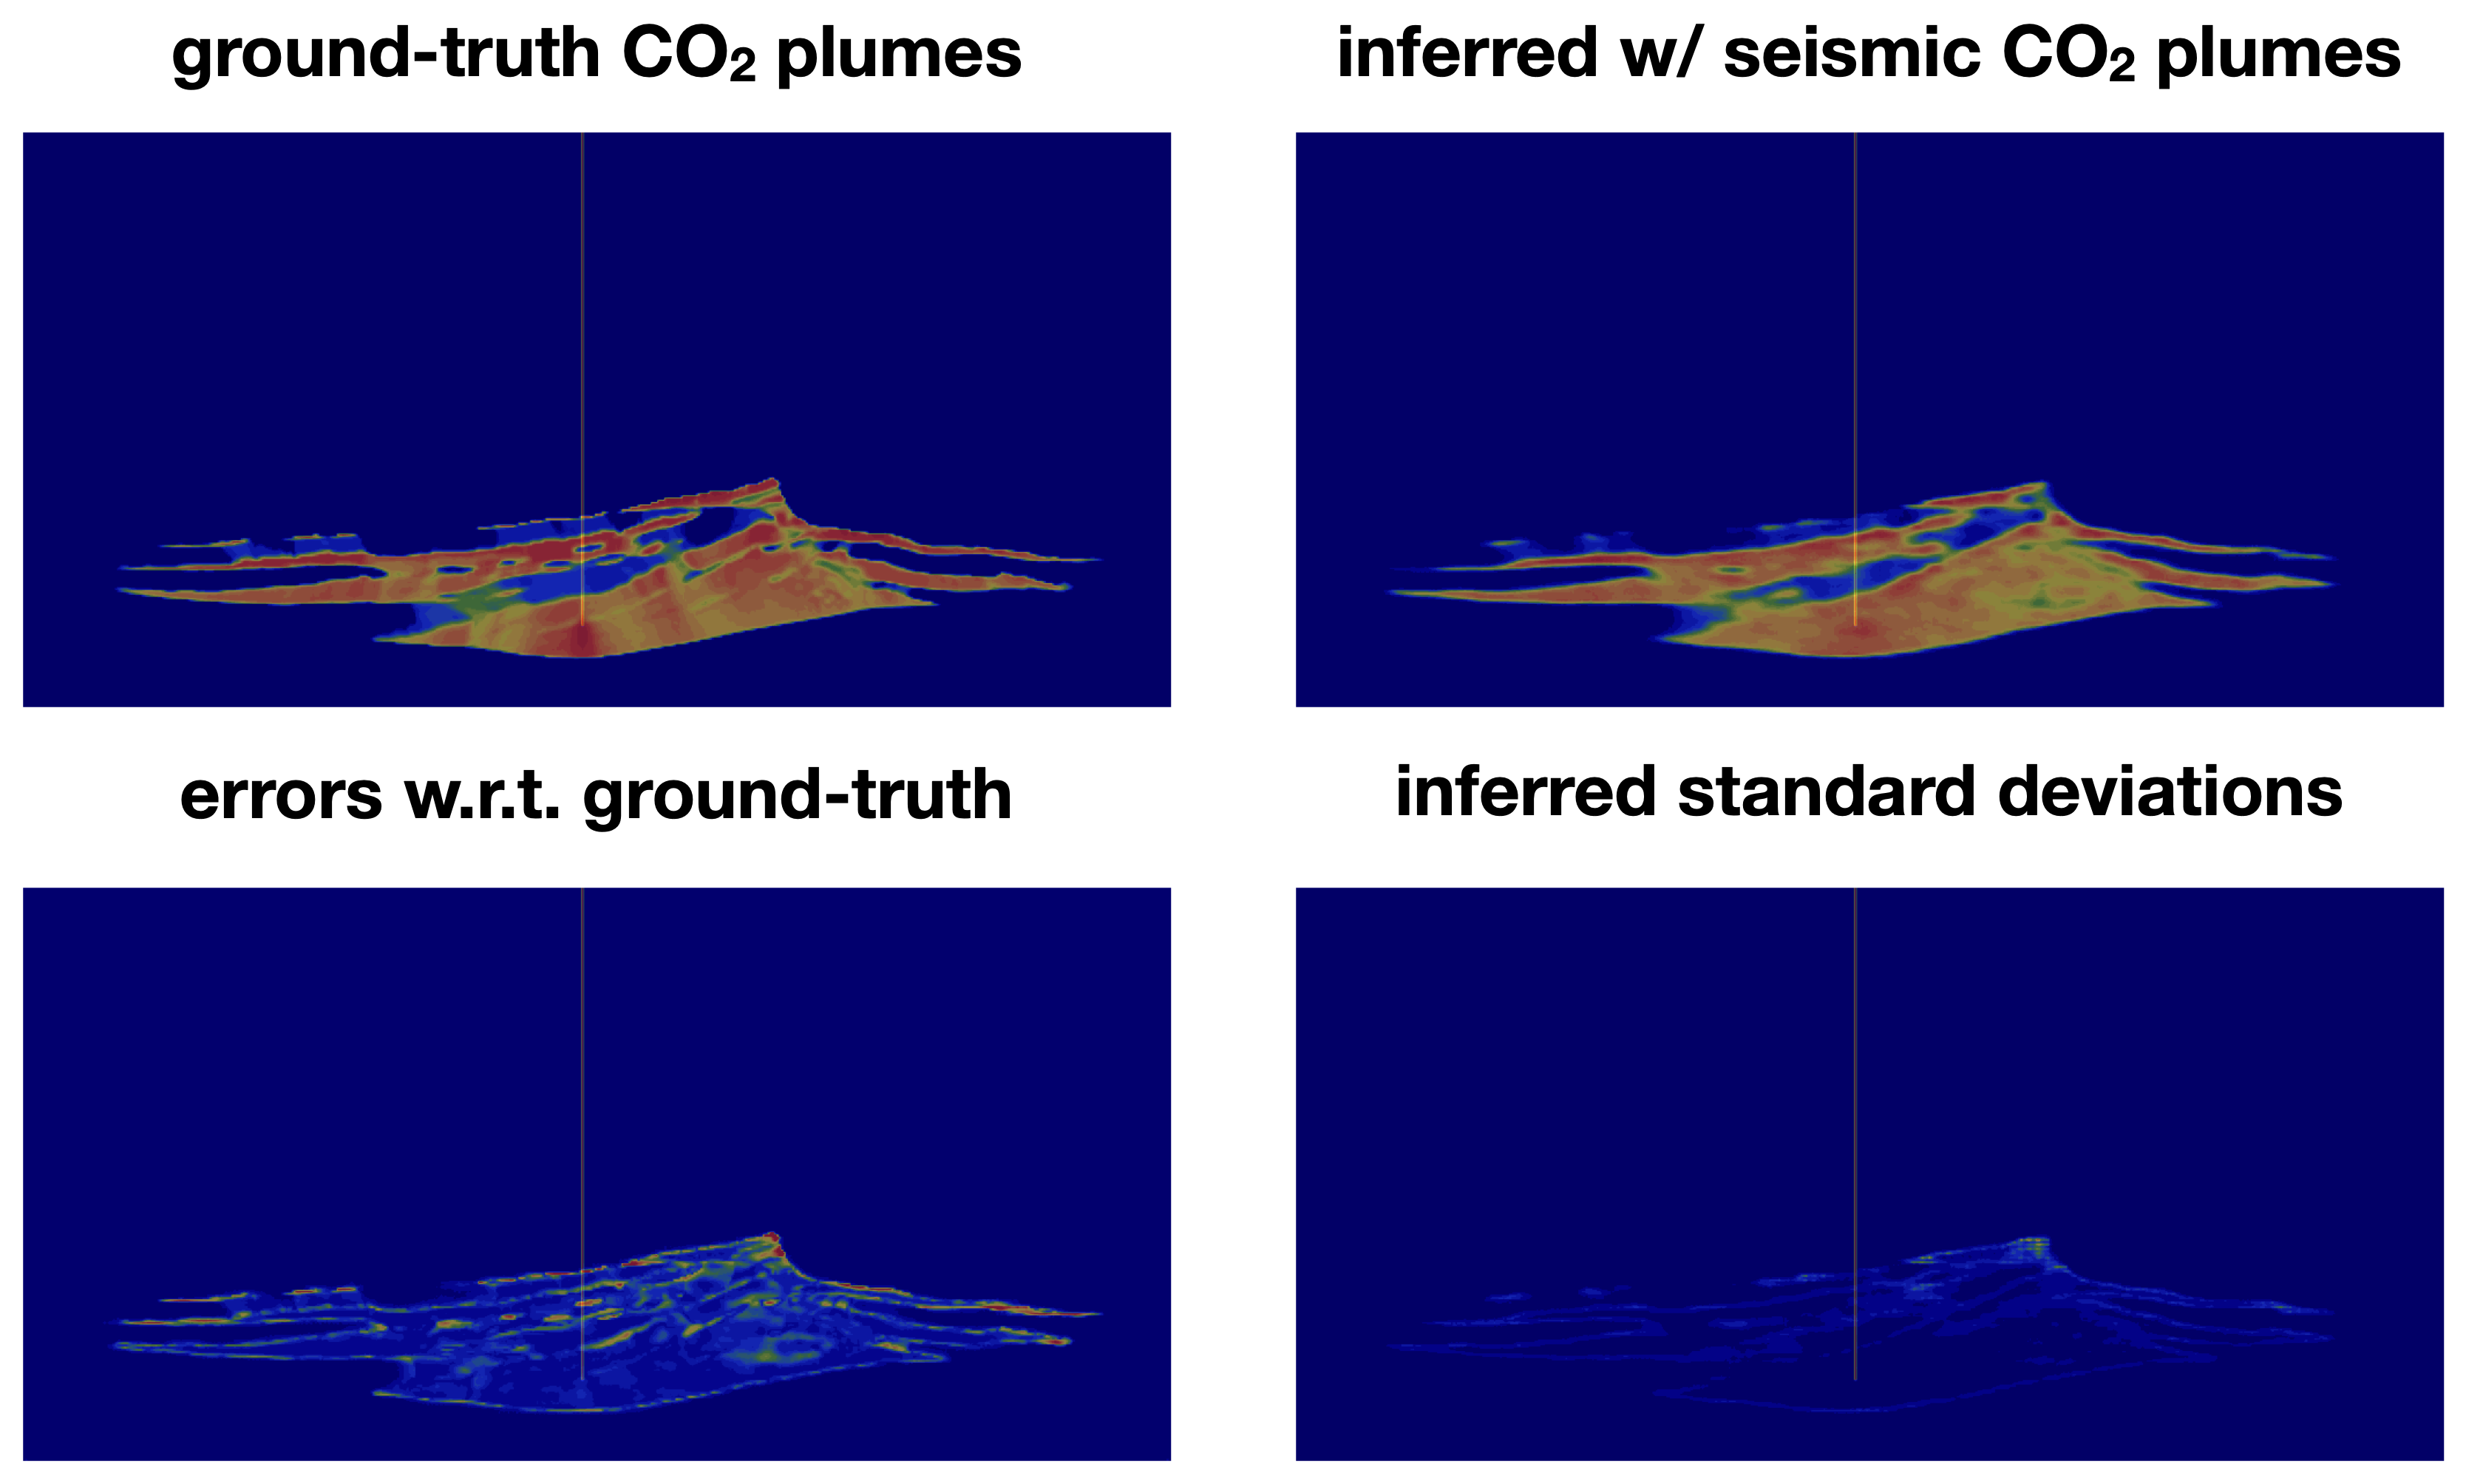
Figure 2: Example of recovered state of the CO₂ plume using 4 time-lapse surveys over a period of XXX years.
Beyond deducing the CO₂ plume’s location and shape (Figure 2), the Digital Twin leverages its neural-density estimation abilities to refine well placements throughout CO₂ injection projects. This optimization is guided by the expected information gain, which quantifies the enhancement in knowledge from prior assumptions accessible during the training phase. Optimized placements, as shown in Figure 3, markedly enhance the CO₂ plume’s delineation over random or ad hoc well placements.
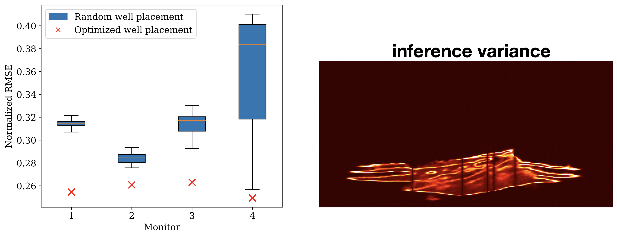
Figure 3: Example of normalized RMSE improvement thanks to well placements that maximize the expected information gain.

